
Kingdom Chancellor Guideline Manual
Amtgard: Kingdom of the Emerald Hills, Inc

Thank you for volunteering for the position of Chancellor the Kingdom of the Emerald Hills. This document was written with the intent of helping you transition you into your new roll. It will explain in great detail all the responsibilities of the position and will help you to navigate through O.R.K. This document should also be used in conjunction with the Park Chancellor Guideline Manual if you are not familiar with park chancellor responsibilities or the basic navigation of O.R.K.

Responsibilities of the Chancellor of the Emerald Hills (EHPM):

O.R.K (Online Record Keeper)

- Enters visitor credits for all of park (established and petitioning) of the Emerald Hills
- Enters all personal information from waivers for new players who choose the kingdom as their residency (known as claiming kingdom)
- Update as needed populace information for players who claim kingdom (i.e. dues, awards, phone #).
- Maintain activity status of populace members who claim kingdom.
- Maintain current contact information for all populace members who claim kingdom
- Provide the local chancellors a accurate voting eligibility (activity as defined in the corpora and dues paid status) list two weeks prior for all kingdom elections and kingdom al-thing
- Provide the GMR (Guildmaster of Reeves) a accurate voting eligibility list (activity as defined in the corpora and dues paid status) list two weeks prior for kingdom PMR and Treasurer elections
- Provide the GMoK (Guildmaster of Knights) an accurate voting eligibility (activity as defined in the knights by-laws and dues paid status) list two weeks prior to Midreign and Coronation.
- Supervise the local park chancellor by auditing their records to make sure they are updating monthly and following any monarchy rules.
- Enter all EH event credits
- Enter all awards given at EH events for EH populace.

Gate for EH Events

- Enters the information gathered from waivers and event contract received from previous event and records received from local park chancellors in the EH gate list.
- Provide gate with waivers, event contracts, EH gate list, sign in sheets and arm bands
- Remind the populace two weeks prior to an event that under 18 will NOT be allowed to enter site with out a waiver and event contract signed by their parent or legal guardian.
- Check in every 6 - 8 hours (or as needed) with gate to see if extra paperwork isn’t needed or there haven’t been any problems.
- Close gate with other kingdom official (preferably Kingdom Treasurer) to gather all signed and blank waivers, event contracts and sign ins, along with gate box (which should include other necessity paperwork i.e. arm bands, pet waivers, etc) and one copy of “Z” report from the cash register.

Publications

- Provide Rulebooks, corpora’s, and newsletters

Elections

- Running all kingdom elections and Al-things (except Chancellor election, those will be ran by the kingdom GMR)

Emerald Hills Website

- Update the dues paid list on the EHPM page
- Update OOK players credit lists

We will now explain the process of O.R.K. O.R.K. is a database that has become the official record keeper of several kingdoms and is maintain by Sir Rewth of the Iron Mountains. Should you have any questions or concerns regarding any system issues please contact him at wraith@frii.com.

The process of entering new players, adding daily credits, maintain contact information, adding populace information (i.e. awards, titles, etc) and maintaining activity status for players who claim kingdom is the same as local players. Please see the park chancellor manual for instruction if needed.

Accessing O.R.K
On the log in screen you will choose the park and enter your password (initial password will be given to you at Midreign by outgoing EHPM). Select kingdom prime minister – read/write. Click on log in.

Entering Visitor Credits

Entering visitor credits can only be done by accessing the write function on O.R.K under the adminstrative section. This can be found under www.Amtgardrecords.com/admin. Each park has a section with the write access.
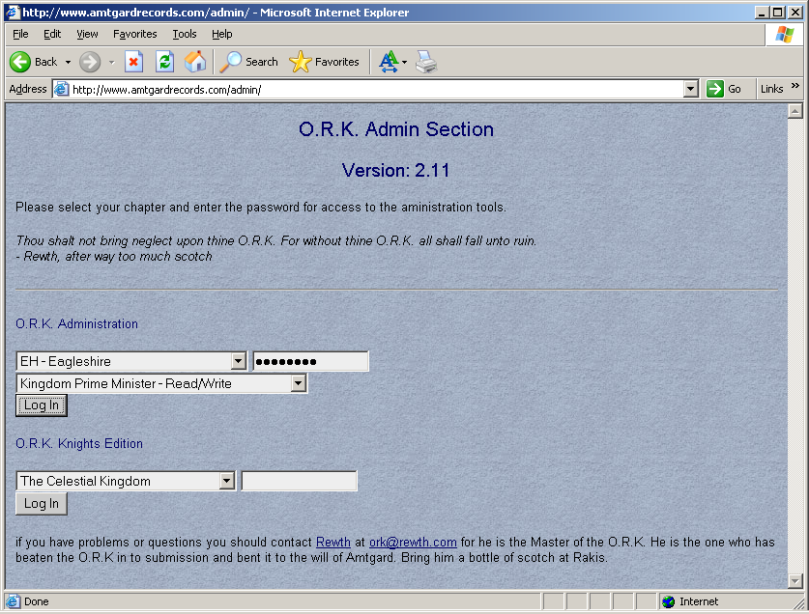
You will first need to pull the visitor report from each park. This can be done by logging into each park and clicking on the command listed as visitors on the left hand side.
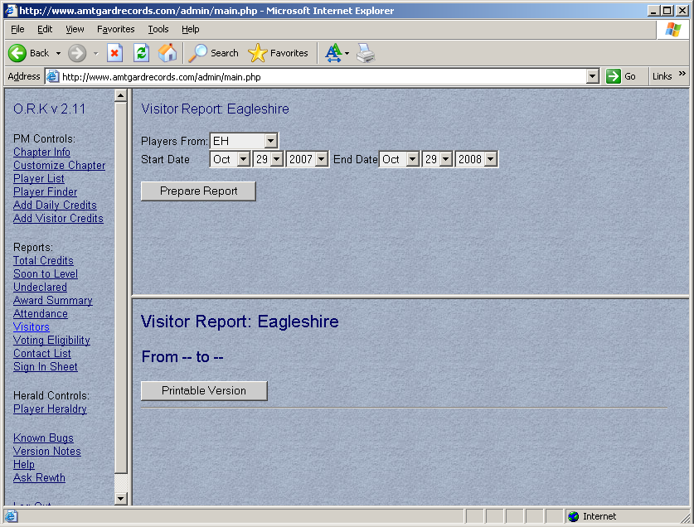
By selecting the drop down menu select ANYWHERE on the “players from:” field.
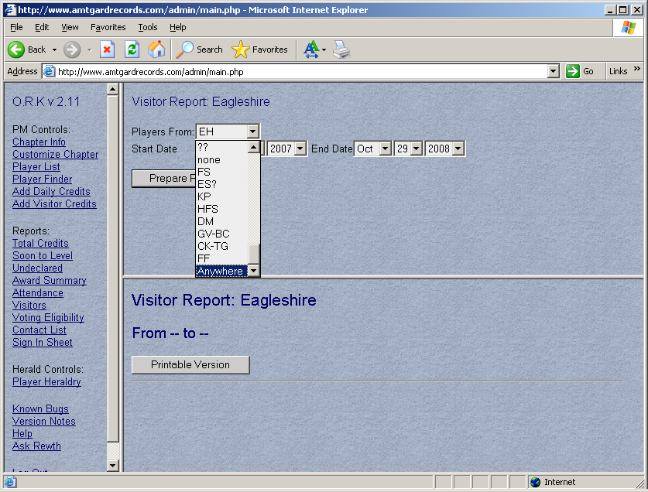
Then select your dates by using the drop down menu (see example below).
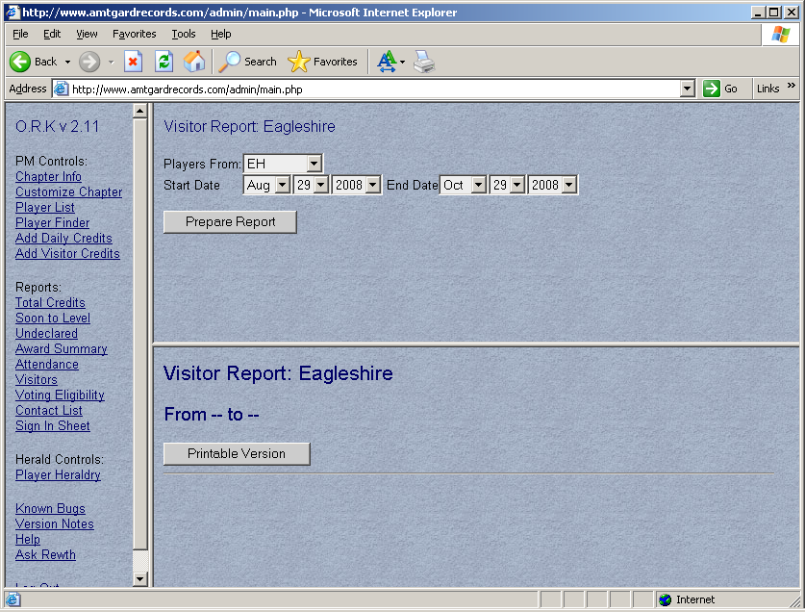 You should always go back 2 months from the end date and your end date should be today’s date. Then click prepare report.
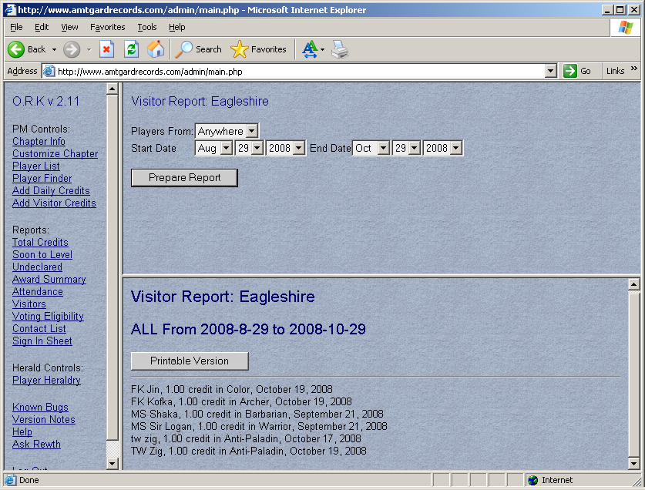
Once the reports are generated then click on printable version. A new screen will pop up, copy and paste all of the information into a word document.
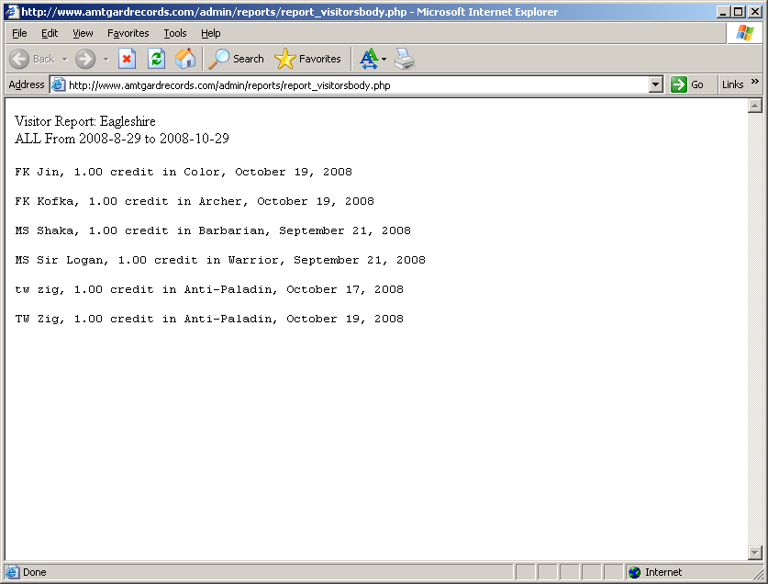

After this is done for the entire local chapter then highlight the players whatever color you find desirable to indicate what park they are from (see example below)


Log in to the each of the local chapters and manually enter the credits into their o.r.k record (see example)
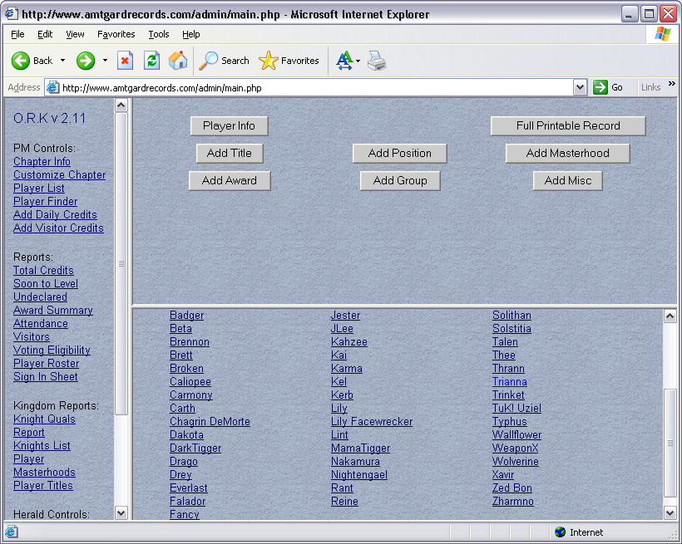
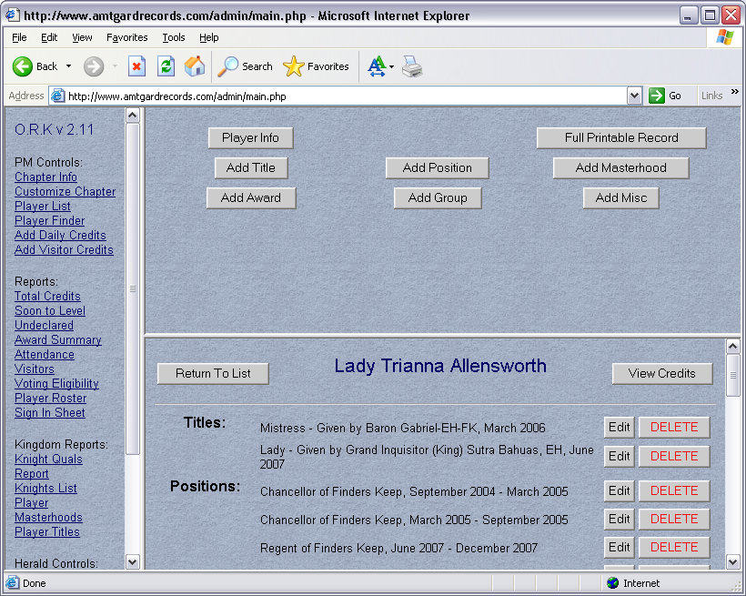
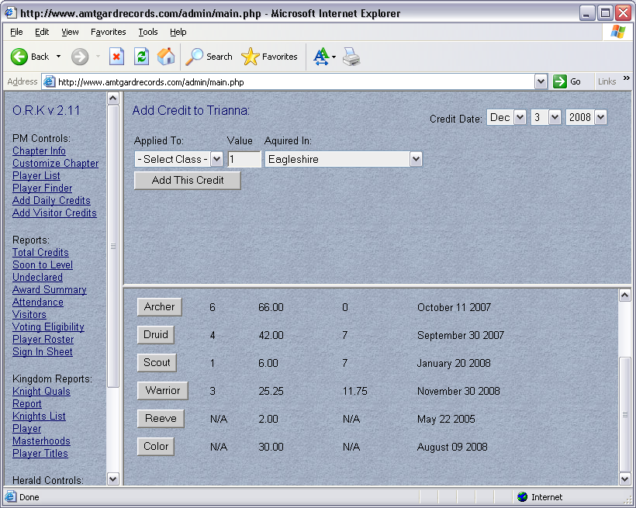

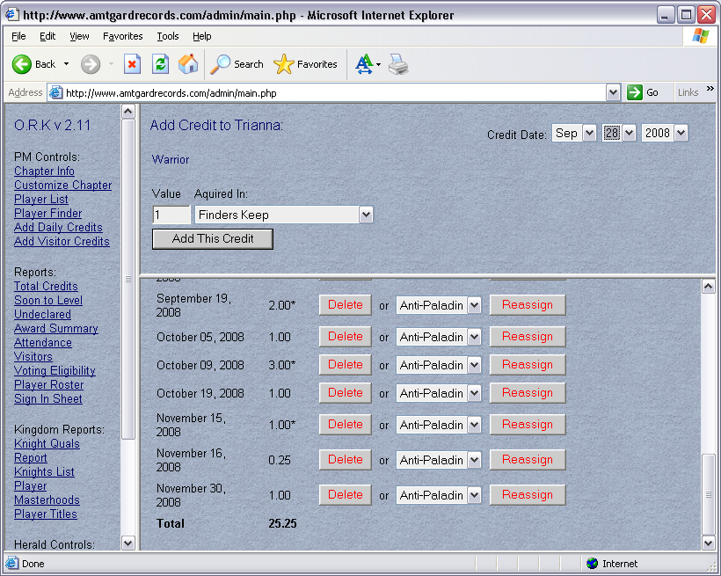

After this is done for all of the members you have successfully have completed entering the visitor credits.

Voting Eligibility
In order to determine if a player is eligible to vote their dues paid and attendance status has to be verified. To verify an activity report and dues paid list will need to be generated.

Activity List
A activity list is how we are able to determine if a player is active according to our corpora requirements of 4 sign ins in a 7 month date span (i.e., knights have a higher standard, see knights by-laws for requirements). The list can only be ran after the entire park and event credits have been entered (please see the section Entering Visitor Credits and Entering Event Credits for questions). Once the credits have been enter, log into the park and click on the list of command to the left labeled “Voting Eligibility” (see example)
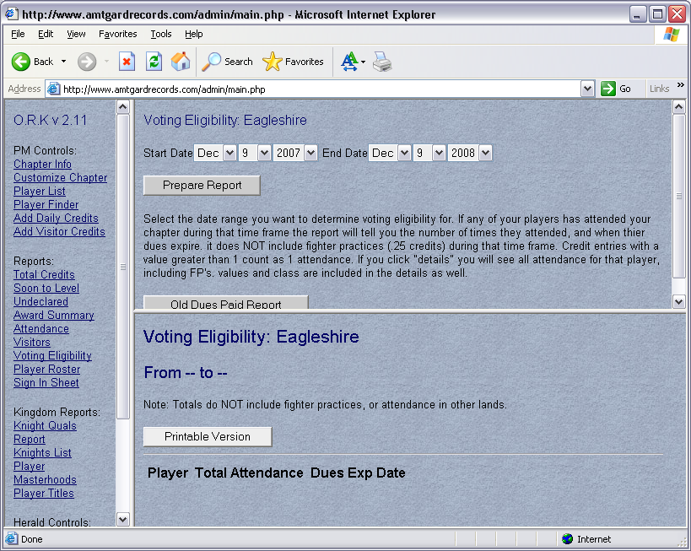

The report will be run for a one year period. The end date should always be two prior to a vote (election, althing or knights vote). The start date should be exactly one year prior to the end date. For example, if the vote is December 13, 2008, the end date would be November 29, 2008 and the start date would be November 29, 2007. Enter the dates and click “Prepare Report”. That will generate the list of all players who have signed in during that date span. Click on “printable version” then copy and paste the list into a word document. With the report still up you will need to click on the “detail” button each player and verify they have 4 sign ins (not credits) during your date span per our corpora of 7 months. For this example it would be April 29, 2008 to November 29, 2008. (See example).
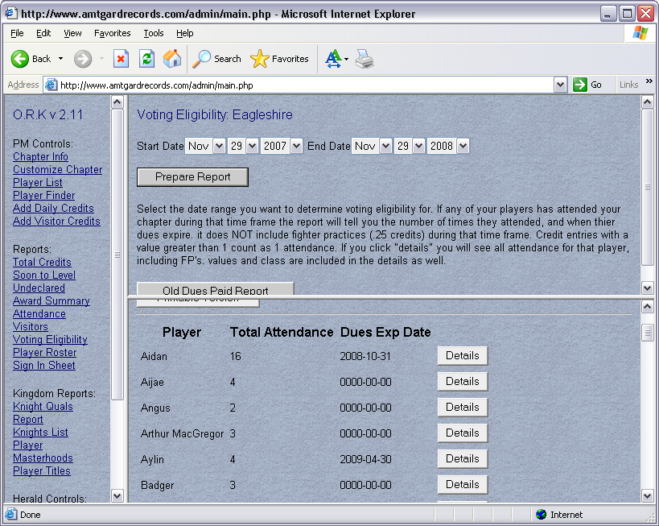
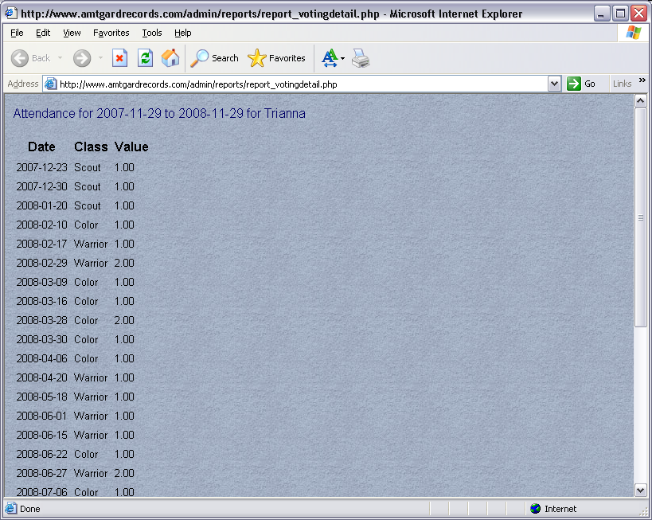
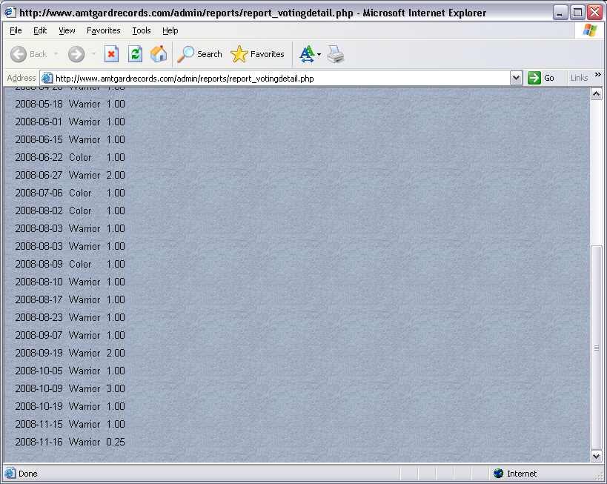
While verifying the attendance you also must exclude players who haven’t claimed our kingdom or have been in the game for 6 months. As you research the attendance you can delete the players who do not meet the activity requirement from your word document.
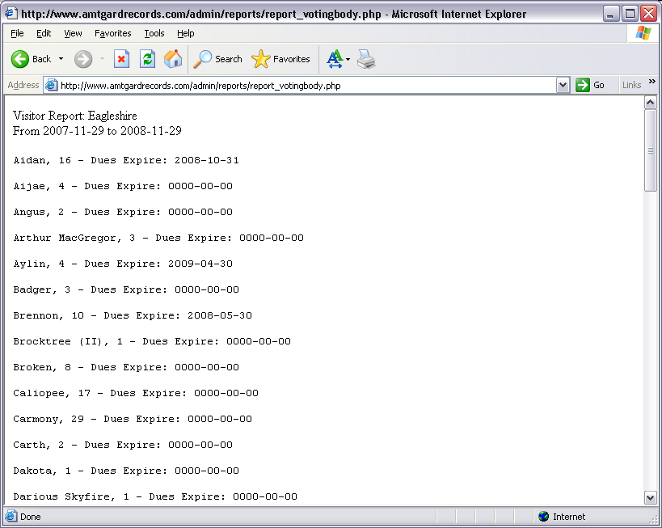

If you need the activity list for the entire kingdom this will be to be done for every park.

Special Circumstances:
Knights Activity: Per the knights by law they are required to have 6 sign ins in a 7 month period. However, 3 of the 6 have to be normal park day attendance. When researching their attendance you must take out kingdom level events such as Weapon master, Dragon Master, and Crown Quals. These dates can be located on the kingdom calendar. A list of our knights can be found at http://www.amtgard-eh.com/knights/default.html.

Dues Paid
Using the same information from the activity list, now look next to the active players name to see if their dues have expired. If their dues have expired or aren’t listed then they are not considered dues paid. If they’re dues paid then DP should be placed next to their name and if they are not then NDP should be placed next to their name. An active player must pay their dues in order to vote.

Once this has been done your activity list has now become a voting eligibity list. This report will be used when determining who is allowed to vote in elections, althing, or knight’s votes.

Entering Event Credits and Awards

Please follow the section listed in the Park Chancellor Guideline Manual, “Entering Daily Credits for populace members” when entering event credits. If you have out of kingdom credits, those will need to be updated on the kingdom website (See instructions under Kingdom Website).

Please follow the sections listed in the Park Chancellor Guideline Manual, “Entering Awards for populace members” for entering awards received for Emerald Hills residents’.

EH Gate

The responsibilities of gate have been divided into three categories, the Monarch, Treasurer and Prime Minister. Your responsibilities are as follows. To remind the populace one to two weeks prior to an event of waiver and event contracts status. This needs to be done especially for players under the age of 18. If their waiver and/or event contract isn’t on file they will not be allow to enter the event. They are also to provide the gate-o-crat with waivers, event contracts, sign ins sheets, gate list, and arm bands for the event. During the event they should check in every 6 - 8 hours (or as needed) to make sure additional paperwork isn’t needed (can be done in conjunction with treasurer drops). The position is also responsible for closing gate with another kingdom officer (preferably the Treasurer). After the event it is your responsibility to update gate list with new waivers and event contract gathered from the event.

Gate List: The gate list is a Microsoft access file that contains waiver information for all players who have attended an EH event. It contains their amtgard and mundane names, dates of birth, email address, emergency contact information and the dates of when their waivers and event contract were signed. This list is maintained and used at gate for a quick reference when signing in without an AMTCARD. The list is also used for AMTCARD holders that are outside our kingdom.

The list is to be updated after every event with the update waiver information gather from gate and park records. Once the information has been transferred from the waiver and event contract they needs to filed away in the kingdom records for safe keeping.
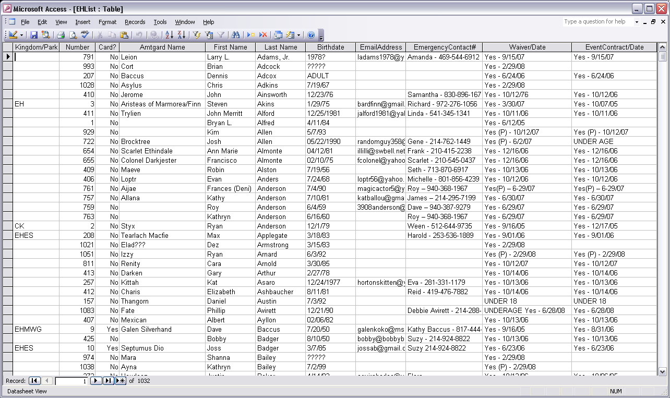

Publications
Rulebooks and Corpora
Every dues paid member in our kingdom is to receive a rule book and corpora. Approximately every 3 months you should inquiry with your parks if they are needed. The kingdom has a laser jet printer that you have access to in order to print your necessary forms, rulebooks, corpora’s or any other publication.

Elections and Althings

It will be your responsibility to run crown elections and althing (Althing are held during the odd months of every reign). The declarations for crown elections should be opened a minimum of two weeks prior to the Sunday of Crown Quals. Once you have opened declaration on both the EH forums and Yahoo List, you will need to keep update them in order to keep the populace well informed.

The voting eligibility list will need to be compiled and posted to the EH website approximately one week prior to elections (see voting eligibly on how to comply list). A notice should be posted to the EH Yahoo List and EH Forums informing the kingdom you have posted the list.

The ballots will need to email to all of the park chancellors approximately one week prior to the elections as well. The current method is a number system with the pms to have the ballot list. The ballot list will contain every active member in the kingdom. The member will sign by their name on the ballot list as well as write their number on their ballot. You will need to create the ballots and ballot list for every election/althing.

An active player may pay their dues, if not dues paid, for both an election and an althing.

Kingdom Website
The kingdom website has a section for you to conduct business, list dues paid players, update waivers, event contracts, and list OOK credits. You will need to have an ftp client server such as Filezilla and either have a website creation application such as Microsoft FrontPage. If you choose to download Fillezilla, be sure you download the client for all servers. If you do not have access to Microsoft FrontPage you can make your changes by coping the HTML coding into notepad and editing the coding. However, if you do not have experience in HTML coding please consult with some who does prior to editing.

The screen shot I will be providing will be from Filezilla and Microsoft FrontPage. You will need to create a fold under your local drive to place the documents.

Logging into the ftp server for the website:
The ftp address is: ftp://www.amtgard-eh.com
Username: Martello_pm
Password: contact the previous EHPM for password
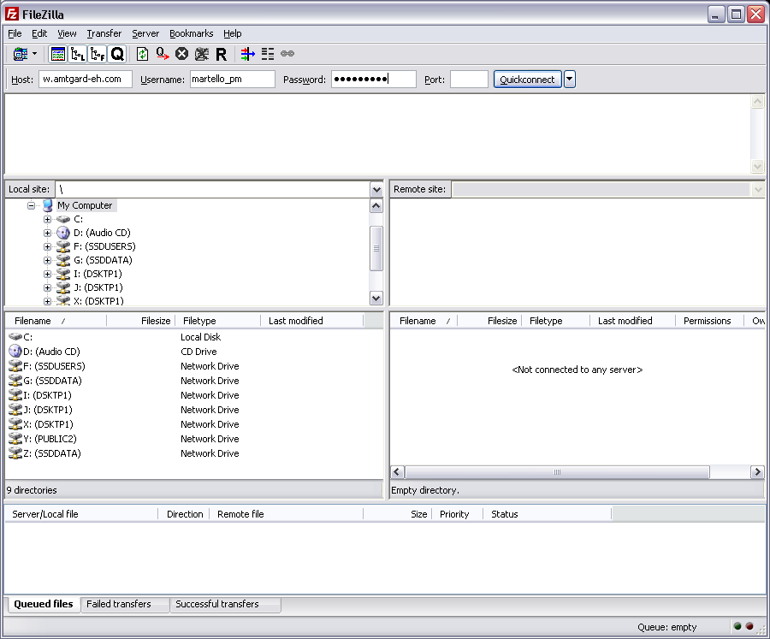

Once you have logged in download the desired page into the file you have chosen. On the file transfer is complete open Microsoft Front page. Open the file you have just download using FrontPage. Using FrontPage it will allow you to make the necessary changes by editing the HTML coding and previewing it prior to uploading. After your changes are complete save file as “save as”, then return to filezila. Your file should be under the “local” side of the application. Open your file and right click on your document and upload the revised file. Once the file has successful transfers close your applications and disconnect from ftp server.

This guideline was written to help you through the transition and will probably not answer every question. As always if you have questions or concerns please consult your Monarch. They are there to help you as you are there to help them.

Written by: Squire Lady Trianna Allensworth

