Amtgard, Inc. 2006
Printed by the Celestial Kingdom, Austin, Texas

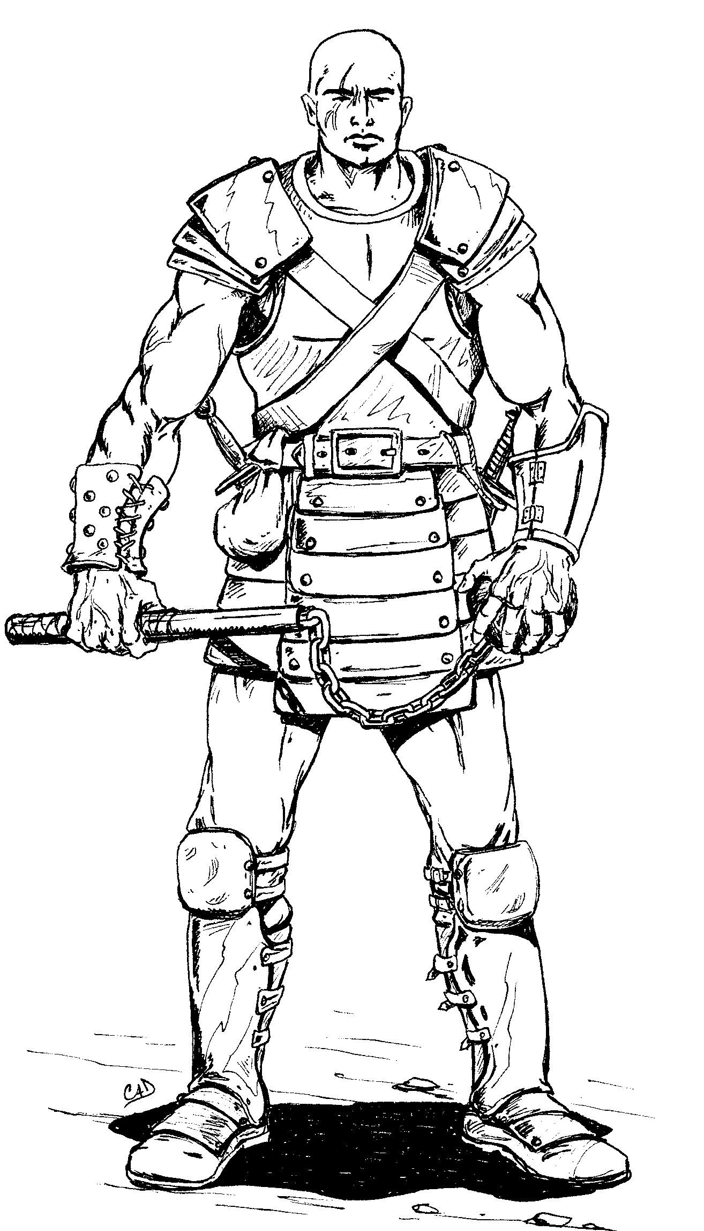
The Star

Of the Celestial Kingdom August 5, 2006
Officers of the Celestial Kingdom

Monarch Prime Minister
Sir Thun Dayne Sir Kanin Wolfkrieger
Jason Peters B.J. Waltersdorf
jpeters@austin.rr.com kaninone@yahoo.com

Regent Champion
Don Diego Velazquez Sir Clalibus Henceforth
Carlos de la Garza Ben Pomerantz
highdancer78747@yahoo.com clalibus@hotmail.com

Guildmaster of Reeves Webminion
Randalf Falconbridge Sponge Harkonnen
Shawn Cavitt Ben
Scavitt13@yahoo.com sponge166@hotmail.com

Board of Directors
Mistie Brown—President Irlen Keys—Treasurer Clark Johnson---Secretary
Ben Pomerantz BJ Waltersdorf Ryan Anderson
Jason Peters--Monarch

Class Guildmasters

Anti-Paladins: Ursor Archers: Oznog Assassins: Axle Barbarians: Bromhir Bards: Jericho Armagh Druids: Ethan
Healer: Colonel Knights: Mistress Wynd Monk: Tatzumake Monsters: Scarlet Paladins: Don Diego Scouts: Maladon Warriors: Lodar Wizards: Sponge

Celestial Kingdom Calendar

August
12-A&S tourney hosted by Mystic Springs, San Antonio, Texas
Contact: Don Diego Velazquez highdancer78747@yahoo.com
17-20- Piratical Sabbatical & Olympiad, Fireman’s Park, Giddings, Texas
Contact: Baroness Ladyhawk Longwing dshawks@hotmail.com
September
1-3- Emerald Hills Midreign at Tanglewood Forest, Corsicana, Texas
Contact: Forest Evergreen forestevergreen@charter.net
2- Kingdom Quest/Dragonmaster, Mary Moore Seawright Park, Austin
Contact: Don Diego highdancer78747@yahoo.com
15-17- Kingdom Midreign, Fireman’s Park, Giddings, Texas
Contact: Countess Squire Akara Akara@planet-save.com
October
1- Collegium at Cecil B. Long Room in Bastrop, Texas
Contact: Don Diego Velazquez highdancer78747@yahoo.com
12-15- World Banner Wars VII, Tanglewood Forest, Corsicana, Texas
Website: http://www.worldbannerwars.org
22- Celestial Kingdom Quals, Traitors’ Gate, McAllister Park, San Antonio
Contact: Don Diego highdancer78747@yahoo.com
November
3-5- Celestial Kingdom Endreign, Fireman’s Park, Giddings, Texas
Contact: Sir Thun Dayne jpeters@austin.rr.com

18


Coats of Arms

The Celestial Kingdom will be holding a competition at kingdom midreign to re-design all the coats of arms within the kingdom. Don’t worry, this is merely a competition for new designs. Any winning designs must still be approved by the home park for the symbol to take effect. However, the primary concern of kingdom is to create coats of arms that are simple and easy to reproduce. The following are merely recommendations:

- No more than 5 colors
- 5 or less main shapes
- No text or writing
- Easily reproduceable
- Must be larger than 4x6 inches

Anyone may enter a coat of arms for any park. Winning designs will receive a cash prize of $10. Good luck!

Don Diego Velazquez

17
Table of Contents

Letter from the King 3
Midreign Flyer 4
Letter from the Regent 5
Arts and Sciences Flyer 6
Piratical Sabbatical 7-8
Olympiad Rules 9-10
Tri-Kingdom Dragonmaster 11-12
World Banner Wars 13-16
Coat of Arms 17
Calendar 18

Please send any future submissions to the Star to Diego at highdancer78747@yahoo.com

From the Desk of the Monarch…
Greetings unto all. Let’s start off with at this point in the reign: attendance is still a very strong issue. Some parks, Bifost and Mystic Springs, are doing very well. Some are doing fairly poorly. Just an idea for some of the park leaders: try spicing up the normal attendance day by doing some games that are different from the normal run of the mill. Clalibus, your champion, has a battle book containing games of a not so regular nature. Please contact him to obtain a copy.
We also have an extremely busy schedule in the next three months. Please check the calendar and try to go to any and everything possible, but at the same time don’t ignore your local parks and encourage others to do this as well.
At this time we would like to ask for volunteers interested in doing some fund raisers for profits to go towards the kingdom storage unit to be erected at Sir Wolfbane’s house. We will also be needing volunteers to raise the building as well. I still have not received a formal bid for Kingdom Quest, tentatively scheduled for the first weekend in September and Spring War already scheduled for spring break next year at Fireman’s Park in Giddings, TX. I will accept bids online and also via snail mail. If you happen to be interested in volunteering or running an event and you have questions, please feel free to call me or contact me on my e-mail. Bids for Spring War will close on the Sunday of Celestial Kingdom Midreign.
In Service to the Celestial Kingdom,
Your Monarch
Sir Thun Dayne 3

14. Dead players must immediately take a knee and put their weapon
on their head. You may not move from where you are when you die
unless Summon Corpse is used or to avoid mundane danger/impeding
play.
15. All rules disputes will be settled by the War-O-Crat, who will
not be playing in the tournament.
16. All sneaky, underhanded, or questionable rules interpretations
or tactics should be cleared with the War-o-Crat BEFORE attempting
to use them.
17. Pole arms will have a restriction of 4 per team of 10' max in
length.

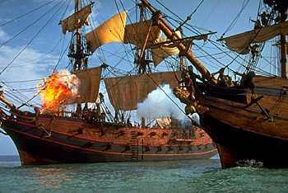

16

Regent’s Letter

The reign has enjoyed its share of successes. Weaponmaster went off well. Ethan and the members of Mystic Springs managed to stick to every single demonstration they had scheduled at the San Antonio public libraries. Having been to three myself, I can attest to the fact that they ran well and showed Amtgard in a very positive light. The Star has seen two issues go out, this being the third. And the calendar has been updated and posted online very regularly.
We’ve also managed to hold one A&S tourney in Bastrop, and another is on the way on the 12th in San Antonio. Olympiad follows the very next week. From then, we can look forward to the three tourneys in the tri-kingdom dragonmaster. Throw in kingdom quals, and there are plenty of opportunities for artisans to shine.
A Collegium has also been scheduled for October, but teachers are coming up short. If you are interested in teaching a class, please let me know ASAP. Collegium can only be as successful as the people that help, so please consider being an instructor. For the rest of you, please come! So far, our instructors are myself, Sir Clalibus, Scarlet, and Ethan…not a bad list.
Get ready for the next few months. It’s a crowded schedule, and there’s lots to do.

Don Diego Velazquez
Regent of the Celestial Kingdom

5

WBW RULES 2006
Team Sign-Ins: 9am-10:00am @ War Field
Only the captain of the team needs to be present to sign-in.

Each captain must provide:
1. A unique banner which should display your company/household/team
symbol.
2. Two copies of every magic-user spell list. You may NOT change
spell lists between rounds.
3. A complete listing of all team members. Members not on this list
will be unable to participate.
4. Every team needs to submit two Reeves to aid in Banner Wars when
not fighting. Note: a Reeves test will be given Friday night by the
GM of Reeves.
5. Armor will be rated Friday night.
Team Composition Rules:
1. Teams are comprised of 14 people and up to four alternates.
2. Alternates may be swapped into the active line-up between rounds.
3. Team members (including alternates) are assigned classes before
the tournament starts and may not switch classes.
4. Your team may have one of each magic using class.
5. Teams may have no more than two bows.
6. Teams may have only one siege weapon mounted on the aft castle of
each ship.
7. Players may only sign up with one team, though pages may be shared
8. Teams do not have to all be from the same company, household,
kingdom, etc. They merely need to all play together and present a
banner with a unique symbol
9. Banners must be a MINIMUM of 2' x 3' (2 feet by 3 feet) in size
and reflect your company/household/team's symbol on it.

14

General Tourney Rules:
1. Tournament will be Double Elimination style.
2. Teams must be ready and in the On-Deck circles for head count and
safety check at the start of the round preceding theirs. When two
teams leave to take the field, the on-deck teams immediately step
into the circles.
3. The tourney field will be 150ft across. But unless your team has
the ability to leave the ship. Entering the water in more than 2 pts
of armor will result in a death. If you step into the armor with no
armor or up to 2 pts will result in a 10 count to climb back aboard
your ship at a designated ladder. All players can access any ladder
they can get to. Staying in the water longer then a 10 count results
in a death, upon entering the water, the player has to go to his/her
knees and get back on the ship as quickly as possible.
4. The battle can be determined in two ways:
A. One team completely eliminating the other
B. One team raising and keeping it's flag (a movable game item not
touchable by the other team) at the aft-castle of the ship for three
consecutive minutes. The flag can be taken into the water but not in
flight.
5. Stepping out of bounds will result in a player being unable to
move their feet for ten seconds and being returned to the point
where they crossed the boundary.
6. Good sportsmanship with be expected and enforced. Arguing with
the reeves or getting into altercations with other players will
result in that person being ejected from the tournament and their
team will be forced to play short a position.
8. Each team may have up to four pages. These pages may only be used
to retrieve your teams spent balls and projectiles.
9. You may not use other teams magic balls, projectiles, or
equipment.
10. Transform and Reincarnate may not be used.
11. No mass spells may be used.
12. The Aft castle on each ship is considered a base for the
purposes of magic and class abilities with the exception of Visit.
13. Your Banners are considered a game item.

15
Celestial Kingdom Midreign
Where: Firemans Park, Giddings, Texas
When: September 15-17
Gate Fee: $10, regardless of day of arrival

Autocrat: Akara
Feast Crat: Diego
Menu: Appetizer: chicken wings, celery, ranch
Main course: barbecue spare ribs, oriental chicken
Side dishes: baked potatoes, peas and carrots
Dessert: Peach Cobbler

Medic: Sir Lady Esoum
Gate: Sir Mistress Wynd O'Onyxloch
Security: Chango

War: Run by Sir Bromhir Ethindale-Tannon,

The Golem Temple War-
Overglorified Good vs Evil war. Each side has a Golem Temple. The good side golems are Earth, Air, Fire, Water and Spirit. The evil side golems are War, Strife, Pestilence, Famine and Darkness. Each team can only use each "element" once. The temples can not be captured or destroyed. Only one golem from each team can be in play at any given time.

4
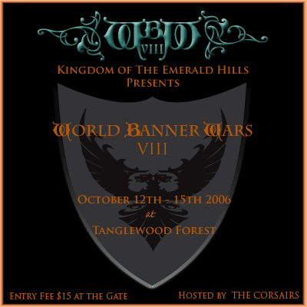

Autocrat Team

Autocrat: Kaz DeKinky War-o-Crat: Falamar LaCrane
kaz@corsairs.org falamar@corsairs.org
A&S-o-Crat: Reine Von Doom Gate-o-Crat: Forest Evergreen
reine@corsairs.org forestevergreen@charter.net
Feast-o-Crat: Tunear Sebeth Pirate Games: Z & Thrasher

13

Kingdom Arts and Sciences Tourney
Hosted by the Shire of Mystic Springs

Where: Mystic Springs, San Pedro Park, San Antonio, Texas
When: July 12, 2006
Sign in begins at noon (or sometime thereabouts)
Judging to begin 1ish (Quest to follow!!!)

Categories:
Owl: Armor, shield, weapon, active construction, passive construction
Dragon: 2-D art, 3-D art, writing
Bardic: music (vocal), music (instrumental), theatrical
Smith: publication, quest write up, instructional material, prose
Garb: accessories, court garb, fighting garb, monster garb

Da Rules: 5 basic categories with several sub-categories.
- No more than 2 entries per subcategory
- Entries will be judged from a scale of 1 to 5 with quarter increments
- Placement will be determined by averaging the five highest entries. In the case of a tie, the six highest entries will be averaged.

Don’t forget some of the following helpful hints:
- Make sure entries are “new”, as in previously unused
- artwork should be well presented, framed if applicable
- musical performances should follow steady rhythm and pitch
- all smith entries should have at least 3 copies for the judges
- garb should be ironed and trimmed of all loose threads

Prizes:
Yes, there will be prizes given out. Money Orders of $25, $20, and $15 for 1st, 2nd, and 3rd place respectively.
6

Piratical Sabbatical II /Olympiad 2006
Wetlands Midreign

Date: August 17-20 at Giddings TX
Gate fee: 20.00 (Ages 5-12 is 5.00/ under 5 is free)

Thursday:
4:00 pm Gate opens/ Begin set up
7:00 pm Early bird tournament: Plank Tournament
Two fighters, single sword, on a plank. Loser truly walks
the plank mateys!

Friday:
9:00 am Early Bird Tournament: 7 Warriors and under
Early Bird Tournament: 7 Warriors and over
Early Cultural Sign-in. Lasts till Noon.
Dragonstorm Camp. Near where Merchant's Row was
last year. Across from the the bathrooms.
Wetlands banner will be flown to signify location.
11:00 am Kids quest
Noon Battlegame - Shore to Ship
3:00 pm Battlegame - Ship to Ship to Ship Battle
5:00 pm Burgers and Dogs begin serving (till 7)
RP Tavern opens - Quests all night!
6:00 pm FEATURED EVENT: Save the Maiden- True Hero's
Obstacle Course
8:00 pm Entertainment/bardic

Saturday:
9:00 am Olympiad Cultural sign-in opens.
Olympiad Warskill sign-in opens.
11:00 am Olympiad Cultural sign-in closes.
Olympiad Warskill sign-in closes.
Reeve & Corpora Tests Administered for PM candidates
Noon Olympiad Cultural judging begins.
Olympiad Warskill Tournament begins.
2:00 pm Amphibious Assault Battlegame
7

Part 2 of the competition will be held at the Mid-Reign of King Thun
Dayne on Sept. 15-17th in Giddings Texas. The Major Categories for this part of the event are Cooking, Writing and Rose.
Cooking: Appetizer, Side Dish, Main Dish, Dessert
Writing: Factual, Fictional, Poetry, Publication
Rose: see above
(Limit on written entries is 5 pages or less - publications excluded)
Part 3 of the competition will be held at the stepping down Coronation of King Redhawk Longwing on Dec. 1-3rd (site TBD). The Major Categories for this part of the event are Construction, Art, and Rose.
Construction: Armor, Shield, Weapon, Passive, Active, and Banner.
Art: 2D, 3D, photography.
Rose: See above.
If you have any questions please contact your Kingdom Regent. I look forward to a highly competitive and good natured series of events.

In Service,
Forest Evergreen

12
Tri-Kingdom Dragonmaster

Greetings,
I know Olympiad is coming up soon, but don't forget that afterwards
there is still a strong cultural competition waiting for you! Tri-Kingdom Dragonmaster! Do you have what it takes to win the title
and beat out competitors in all 3 kingdoms? Participants will be
allowed 3 items per individual category with only the top 2 in that
category counting towards your score. (i.e. You can enter 3 Singing
pieces, but only 2 will count towards your score). Scores will be
determined by subtracting 3.5 from an items score and adding any
positive remainder to a participants point total. (i.e. if you had
scores of 3.75, 4.0, and 2.9 you would have a total of .75 points
towards you over all score). This ensures only above average items will aid you in your quest to win. The entrant with the highest point total after all 3 parts of the competition will be the winner and will be
granted the title of Tri-Kingdom Dragonmaster!

The first part of Tri-Kingdom Dragonmaster will be held at the Mid-Reign of Queen Reine von Doom on Sept 1-3rd at Tanglewood Forest. The Major Categories for this part of the event are Bardic, Garb, and Rose.
Bardic: Singing, Oratory, Dancing, and Instrumental.
Garb: Court, Fighting, Monster, Accessory, Belt Favor
Rose: Any entry that is a donation to the game as is to be judged on its usefulness.
11
4:00 pm FEATURED EVENT: Pirate Olympics
1. Dagger Throwing
2. Peg Leg Races
3. One Eyed event of some sort
4. Sword and off hand beer tournament
6:00 pm Feast - We promise that feast will be on-time.
We will eat while it is daylight.
7:00 pm Court - Let's keep it short ;)
8:00 pm We paaarrrty!

Sunday:
10:00 am Kingdom Althing & PM Elections
Clean it up, pack it up, get the hell out.

Save the Maiden: True Hero Obstacle Course

This obstacle course will be fraught with danger and peril (no...it's too perilous for you!). You must bring all of your Amtgard skills with you.
We are looking for true heroes to get through all the dangers and to ultimately Save the Maiden!!! The hero who does so in the fastest time
will be deemed the True Hero. This is a booty tournament!

Pirate Olympics!
The Pirates only get together once a year. So, they must find out who is the best pirate around. The winner will be declared the Best Pirate
of 2006 and will take home Pirate Booty. Booty for runners up as well!
Events include: Peg Leg races (with real peg legs), knife throwing, One Eyed Parrot Tossing, and other Pirate skill events.

Shore to Ship Battle
One team is in a ship. The other team must get to the ship via pirogues (That be a fancy way to be sayin' a dingy)

Ship to Ship to Ship Battle
That be a right problem Cap'n! There be one ship to Starboard, and one ship to Port. Yer orders, Cap'n?

Amphibious Assault
Just like battle one....but in reverse.! Keep our Piratical Sabbatical Island safe from the Royals!
8
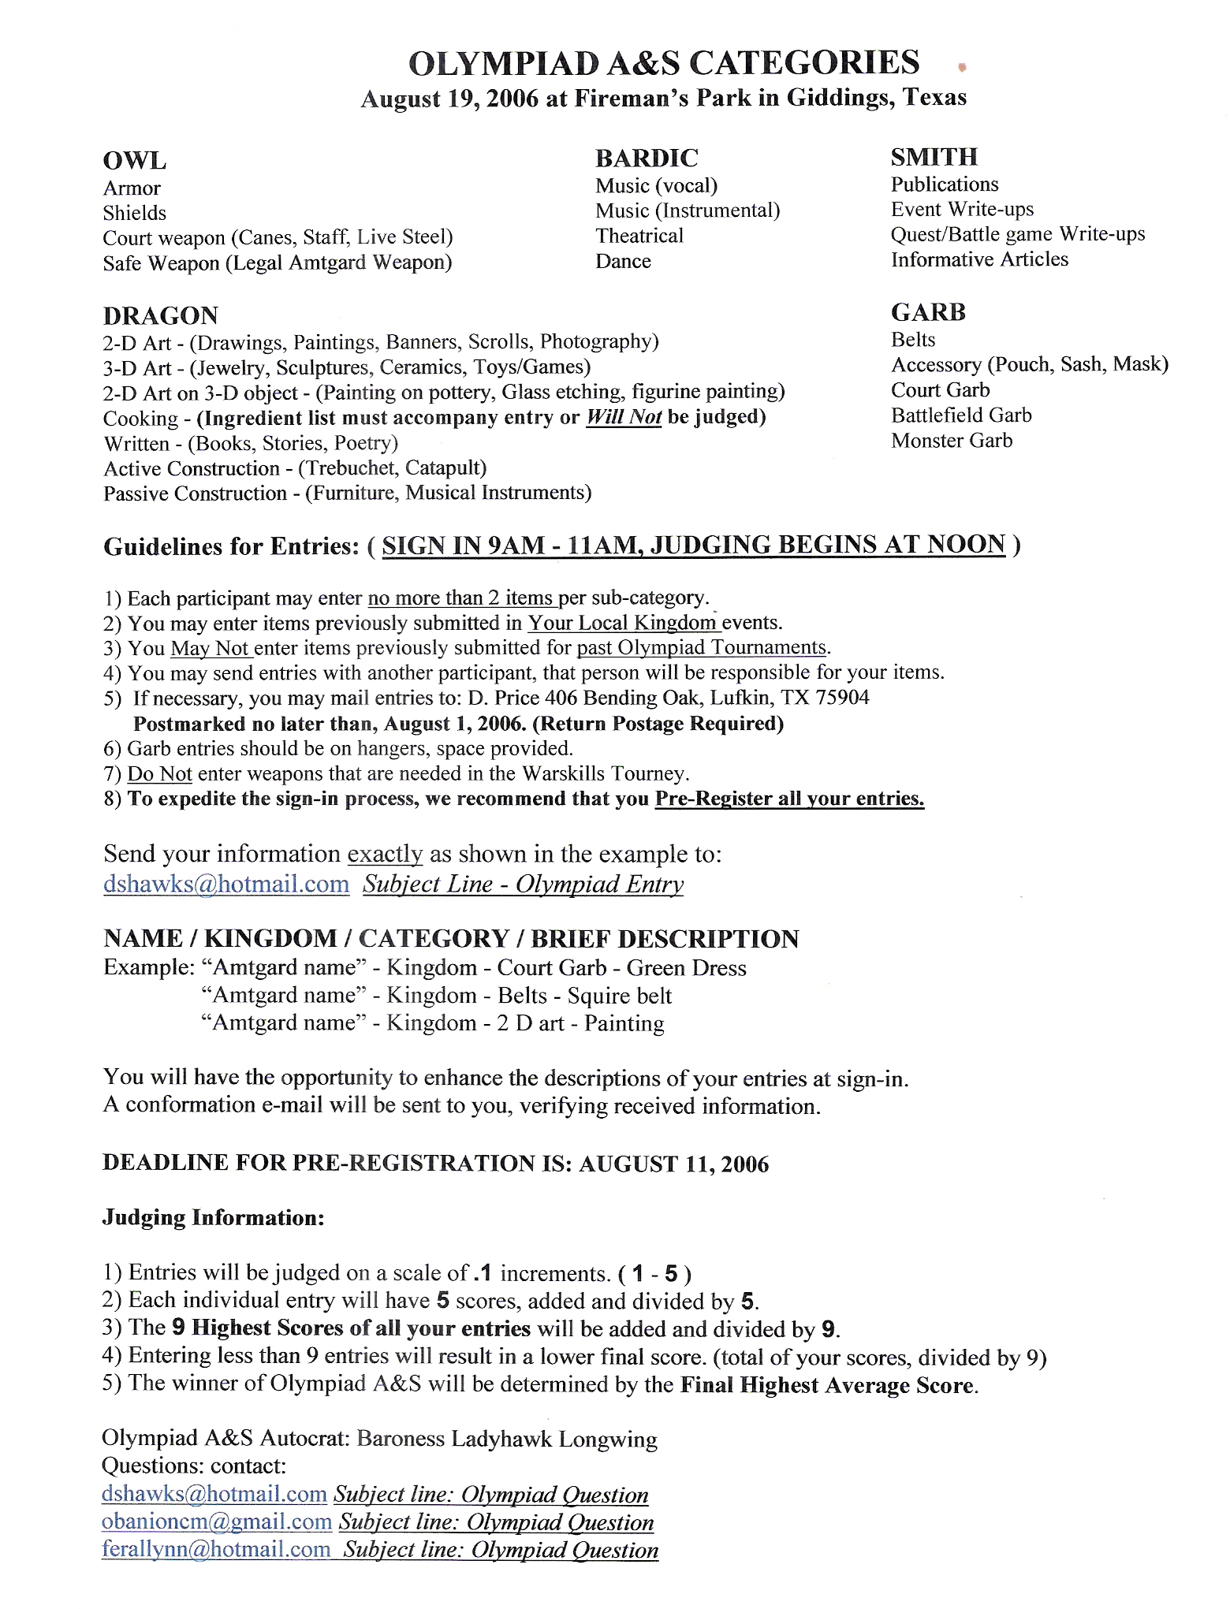

9

TOURNAMENTS
* Single Short Sword
* Short Sword & Shield
* Florentine Short Sword
* Great Weapon (Any weapon over 5ft)
* Open Weapon

SIGN IN

Sign in begins at 9 a.m. & promptly closes at 11 a.m. It is during this time you will be given your entrant number. Keep up with what your number is because it is how you will be called out to the field.
It's the hope of the autocrat that all tournaments will be seeded and we can begin fighting around the noon hour. However, sometimes things happen and we might get started a little late. Keep in mind that I might have a crack team of experts in place and we may get started a little early. It would be wise to be at the determined fighting area by 11:30
In the interest of making it easier on the reeves, list masters and autocrats when combatants sign in they will be assigned a number. These will be the numbers that list masters call out to send combatants to the appropriate fighting rings. We will not be calling you by name.

SEEDING THE TOURNAMENT
How will we be doing it? Are we spinning chickens? Counting Dwarfs? Nope. Neither of those. We're going to keep it fairly low tech and kill a few trees in the process. Why? Because technology complicates more things than it helps
sometimes. When it is determined how many fighters we have we will place cards with numbers into a drop box and begin drawing them out to seed the tournaments. Once we have the first few tournaments seeded, we will begin our fighting
extravaganza. While those tournaments are in progress we will continue to seed the tournaments until we have all brackets filled. Just be sure to remember your number please.

SCORING
Points will be awarded to the top 3 fighters in each category. First place will be awarded five points, Second will be awarded three points and Third place will be awarded with one point. Determining who is first second and third will be simple.
During the semi final round when we are down to only four combatants, Fighters#1 & #2 will fight and #3 & #4 will fight. The losers from the first fight will fight each other for the third slot in the top three combatants. These three
combatants will fight round robin for first through third place.
In case of a tie in the number of points between entrants, there will be a sudden death match. The sudden death match weapon combo will be mutually agreed upon by both combatants. Should the combatants be unable to agree on a combo, it will
be randomly determined by random drawing by the tournament autocrats. The two combatants will fight three rounds. Best two of three rounds will be awarded an extra death match point and be declared the overall Warskill Olympian.

10

