Park Chancellor Guideline Manual

Amtgard: Kingdom of the Emerald Hills, Inc

Thank you for volunteering for the position of chancellor (prime minister) for your local park. As you will soon find, the position of a local PM is extremely vital to our organization and has many responsibilities. This document will attempt to explain in detail what your responsibilities are and how to navigate through the Online Record Keeper (O.R.K.) and work with the Kingdom Prime Minister of Records (PMR).

O.R.K is the official record keeper of the Emerald Hills. You must enter all information there.
- Enter daily credits from sign in sheets
- Enter all personal information from waivers for new players
- Update populace information as needed (i.e. dues, awards, change of information)
- Maintain activity status of populace members
- Maintain current contact information for all local populace members.
- Report to the Kingdom PMR on a monthly (at minimum) basis all park sign ins & waivers.

Forms that you are to provide for the populace
- Corpora and Rulebooks for members paying dues (upon request)
- Waivers (new ones need to be filled out every 4 years)
- Sign in sheets
- Receipts for dues with updating dues paid book

Elections
It will be your responsibility to hold all kingdom and park level elections and althings, except the Chancellor elections, which the park Monarch or GMR will hold. You will need to create and print ballots for all dues paid members. The results from kingdom elections will need to be reported to the kingdom PMR no later than the declared deadline.

Records
At every Mid-reign and Coronation you will need to provide copies of all new waivers, sign-in sheets, and kingdom election ballots to the current PMR.

Treasury
You will also maintain current and accurate records of the park treasury. You should also be available when the park Monarch needs access to the park treasury. You also have authorization to spend up to 10% of the park treasury to purchase items for your office (i.e. paper, pens, and copies) per month.

Online Record Keeper (O.R.K.)
Now we will explain the process of using the O.R.K. The O.R.K. is a database that is maintained by Sir Rewth of the Iron Mountains. Should you have any questions or concerns regarding any system issues please contact him at ork@amtgardrecords.com.

Logging In to O.R.K

Go to your internet browser, such as internet explorer or mozilla
At the address bar enter www.amtgardrecords.com/admin click “go”
Under the O.R.K Administration pull down the drop down menu and select your local chapter (i.e. EH – Eagleshire).
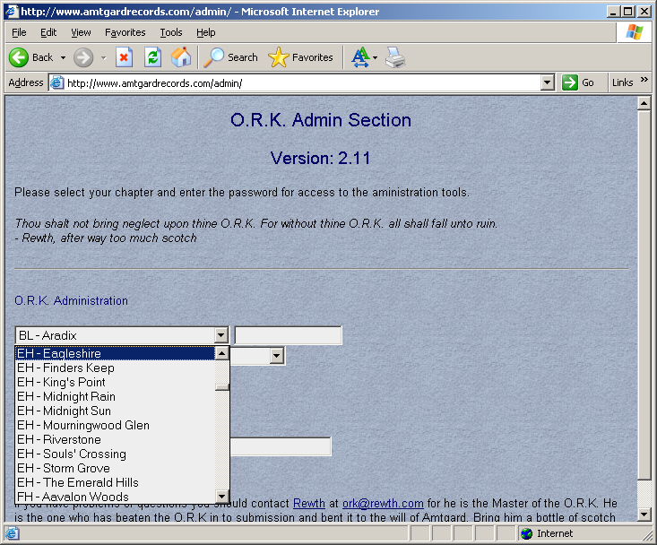
Tab to the next field and type in your password.
Then choose Chapter Prime Minister – Read/Write function
Click Log In
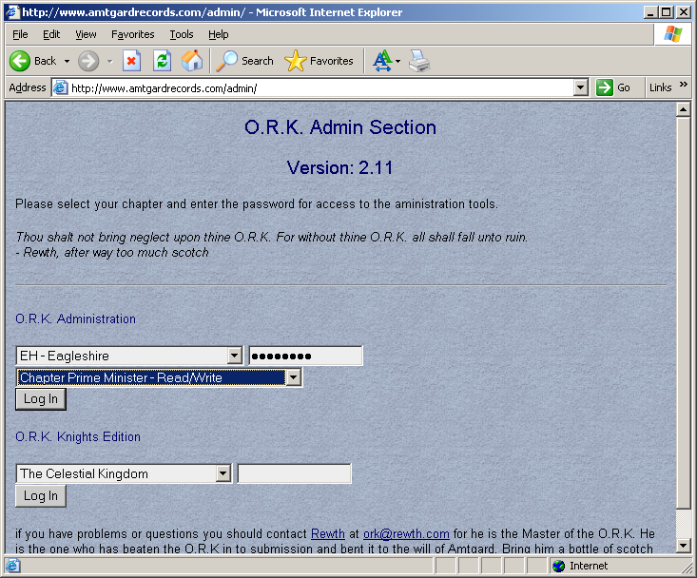
This will take you to your password screen. This screen will show you the monarchy read only password as well as your local password. If you need to change your password you can do so on this screen by simply changing the password and clicking on “apply these changes”. Please do not change the kingdom’s read only password.

If you look to your left, there is a list of commands. These commands will navigate you through the different sections of your o.r.k records.

Entering new players into the o.k. database

Prior to creating a new player entry, make certain the player doesn’t already have an O.R.K. record. If they do, contact the kingdom PMR to have the player transferred to your park. If they do not, then select player list from the command list on the left side of the screen.
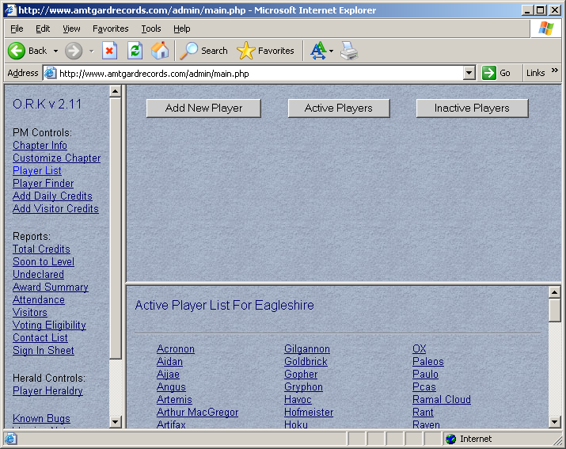
Click on Add New Player, using the information from the new player’s waiver enter the information into the screen listed below. For voting purposes, if your player is under the age of 14 enter their date of birth.
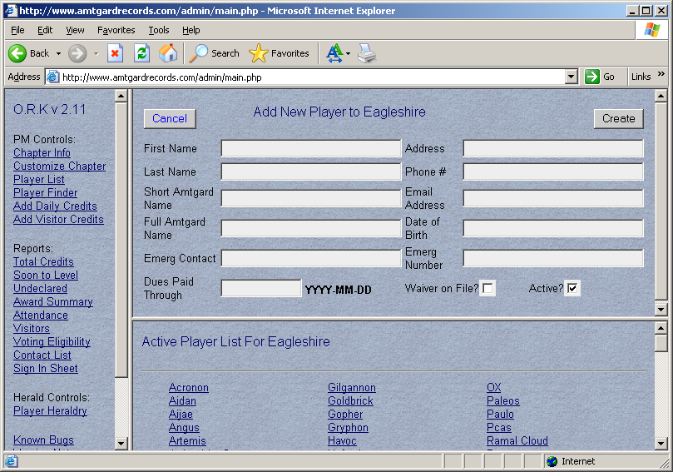
After the information has been entered, click on create. The new player record has now been created.

Entering Daily Credits for populace members

Entering credits from your local chapter needs to be done a minimum of once a month per our corpora, although it is recommended you enter them once a week so that nothing falls behind.

On the command list to the left click on “Add Daily Credits”.
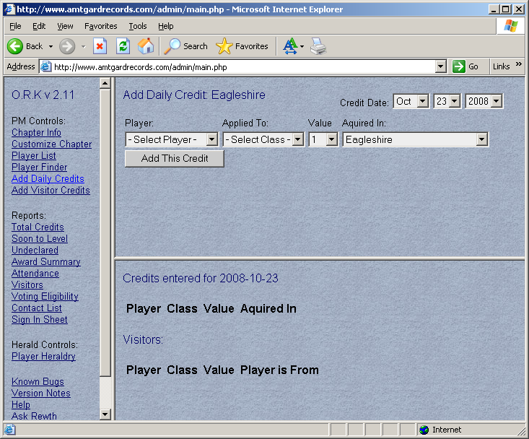
Under “credit date” select the month, date and year of your entry. By using the drop down menu you can select the player’s name, what class they have chosen, how many credits they’ve earned that day. After your selections have been made click “add this credit.” (See example below). The credit has been added to their record. Repeat this procedure for all of your populace members who have signed in for that particular day. Unless you have been granted special permission from the Kingdom Monarch, you should not award more that 1 credit to a player on a park day.
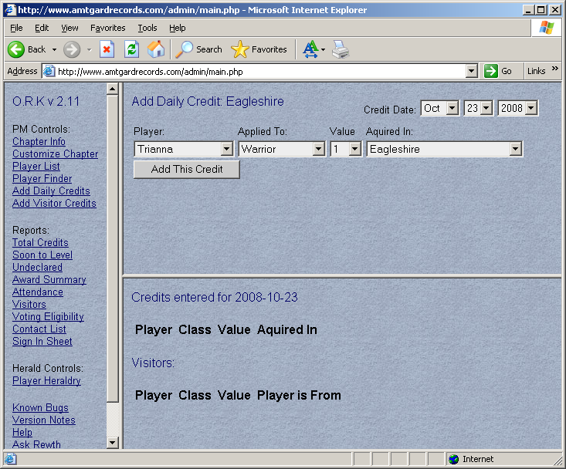

Entering daily credits for visiting players

Using the command list on the left side, click on “add visitor credits”. Enter the visiting player name under “player name”, enter the chapter they are from in this suggested format (Chapter Abbr Suggested Format: KK-CC where KK=two letter kingdom abbr, CC= two letter chapter abbr, so IM-NH would be The Northern Holdfast in the Iron Mountains.) under Home Abbr. Select the class using the drop down menu (see example below) and click “add this credit”. The credit for this play has been added once you see it below.
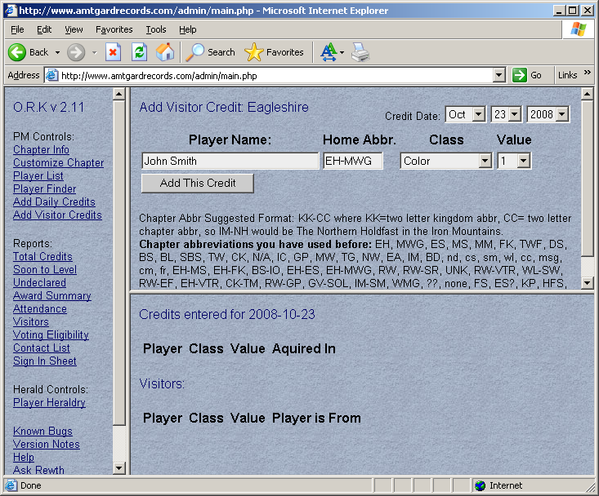

Entering Awards for populace members

Awards received from your local chapter will need to be added to the player’s record. All kingdom level awards will be entered by the Kingdom PMR. To enter local level awards access the player list from the list of command on the left. Click on the player list and search the list for the player who has earned the award. After the player has been located click on their name.
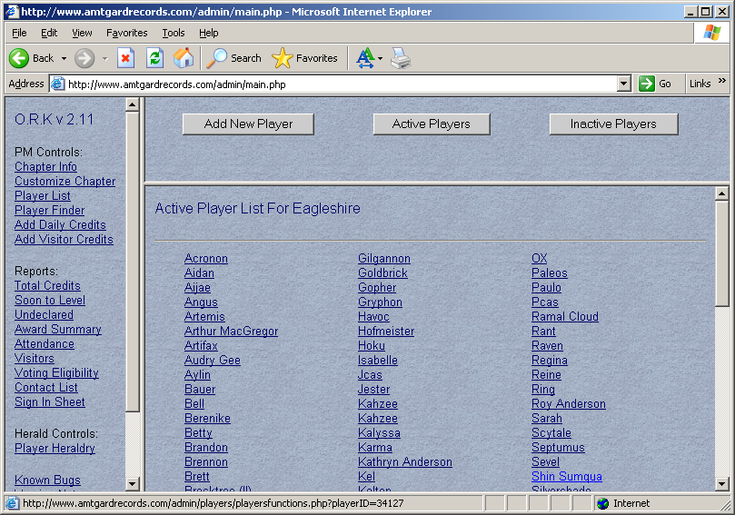
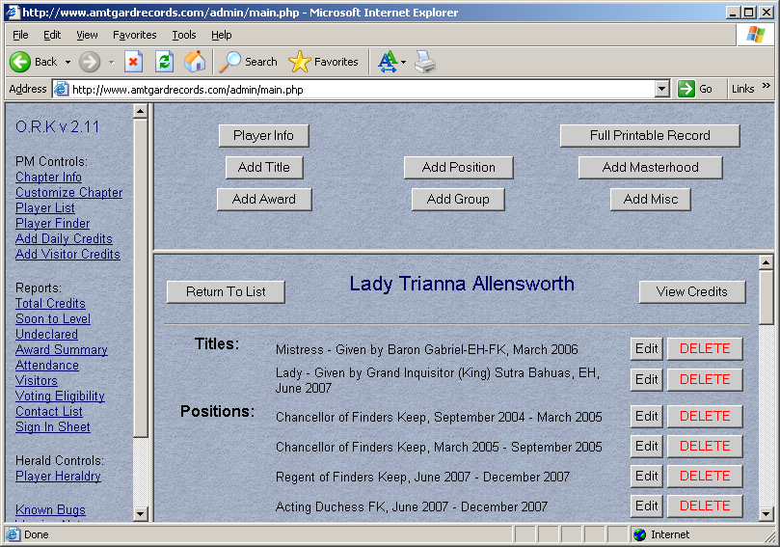
Click on add award
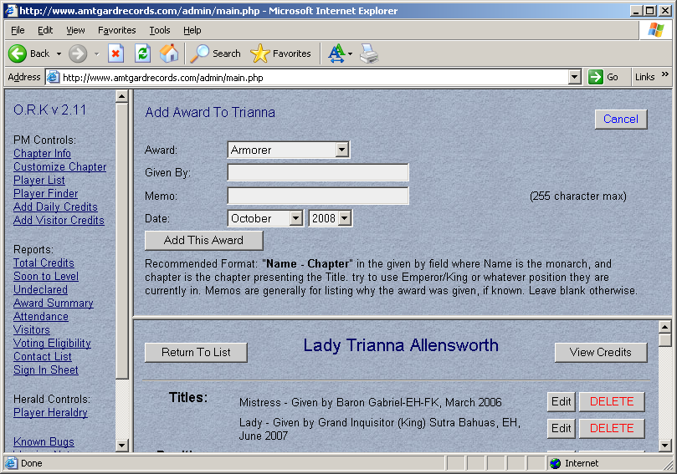
Select the type of award given by selecting the drop down menu.
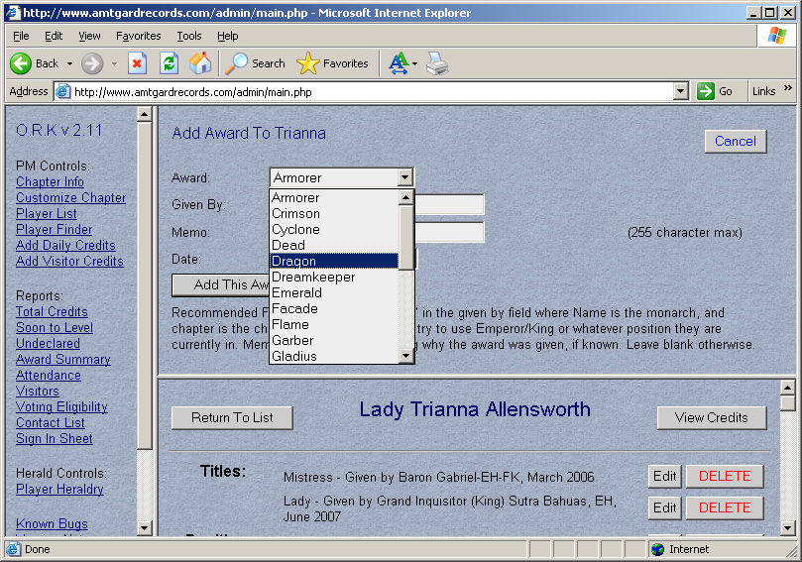
Enter the monarch and regent (using their full title) name in the given by field. It is very important to also notate the reason for the award as this could possibly affect awards received at a later date. Then finally enter the month and year the award was received. Then click on “add this award”. The same procedures will be used for editing awards, adding titles, masterhoods, positions, and groups.

Maintaining Active Status for populace members
There will be time when a player takes a break for an extended period of time. When this happens it is very important to change their status to “inactive”. It helps the kingdom PMR when he/she runs the voting eligibility lists for elections, knighting voting and al-things.

To do this you will access the player list by clicking on “player list” from the list of commands on the left.
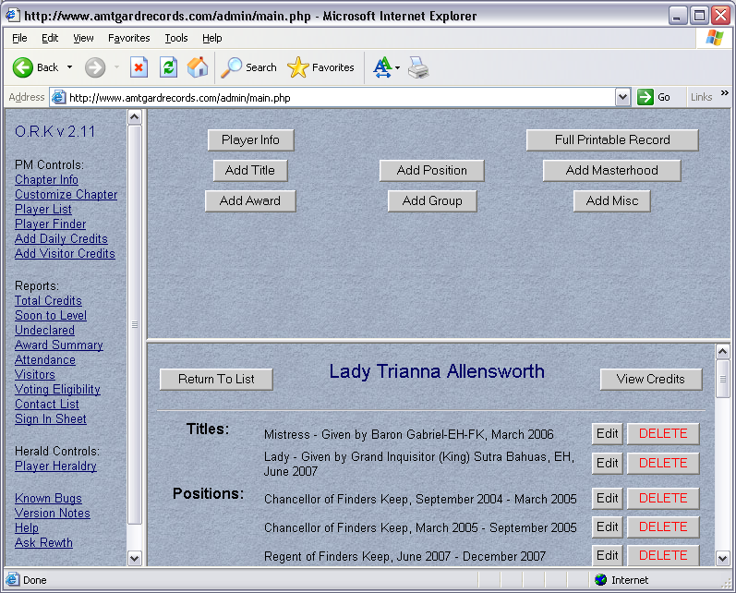
Click on “view credits”. This will show you their credits for all of the classes played. If their last sign in hasn’t been within a year from today’s date then they are to be considered inactive.
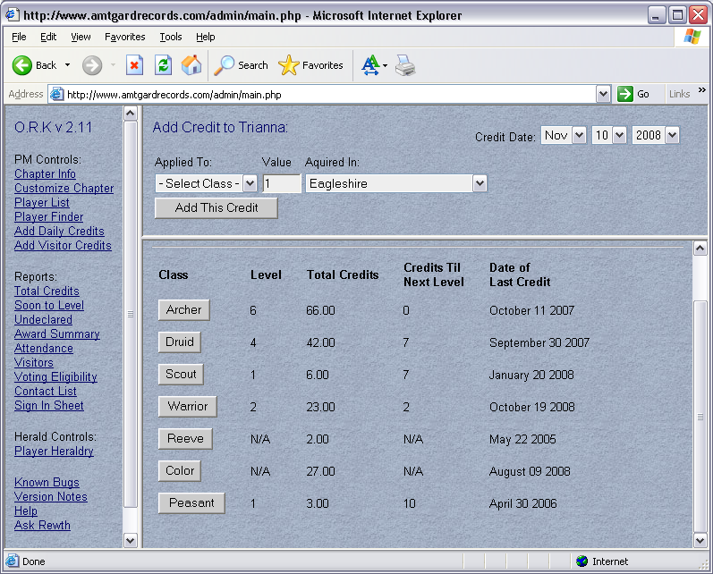
To move a player to an “inactive status” click “view player”. Click on “player info”. You will see towards the bottom a box listed “active”. Unclick the box and click on “apply these changes”. Your player will be moved to the inactive section. If the player comes back out you will need to reactivate their record before they will show in your drop down menus or reports.
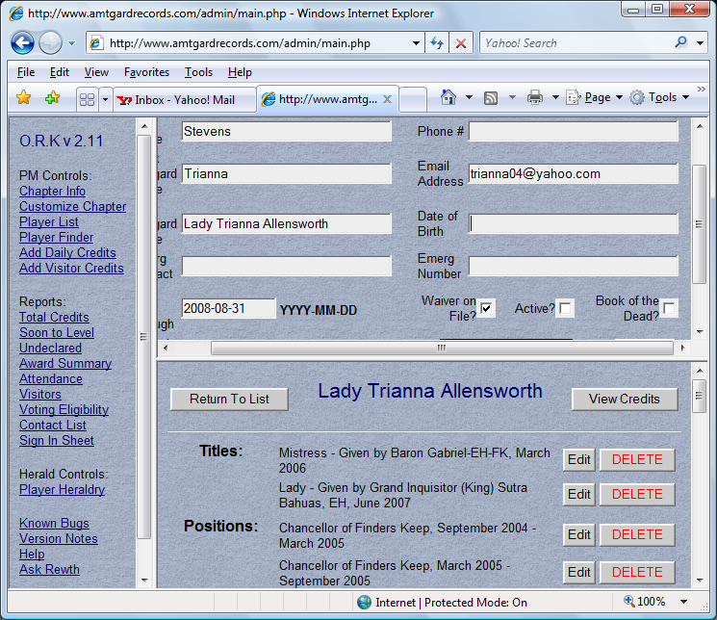

Required Forms
The following are the forms required for our kingdom.
- Sign In Sheet
- Participation Waiver
- EH Event Contract
If a player wants to participate in Amtgard regardless of level of participation they must have a signed waiver on file. If the play is under 18 the waiver MUST be completed by their parent or legal guardian. If a player wants to attend a kingdom event the EH Event Contract must also be filled out by the player or their parent or legal guardian if they are under 18.

